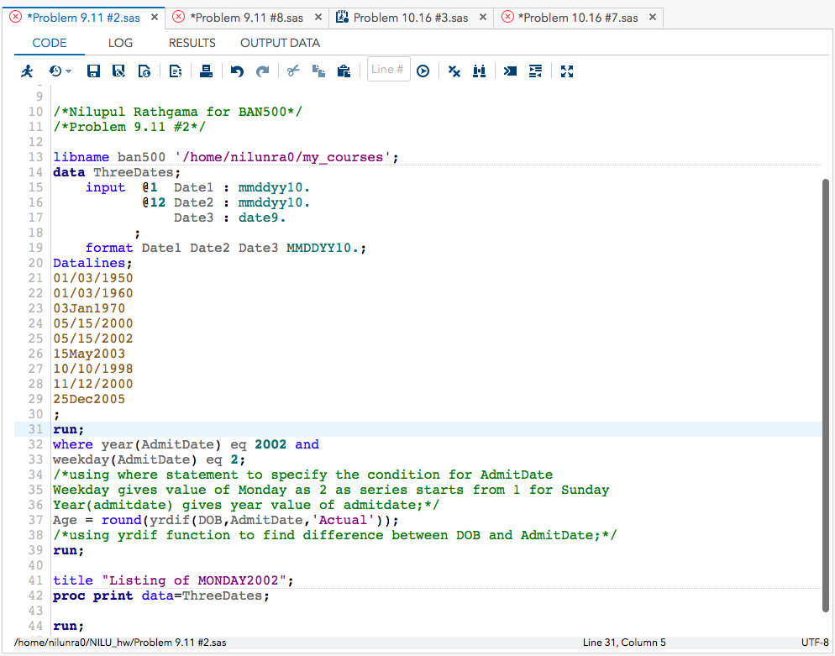Problem 9.11 #2

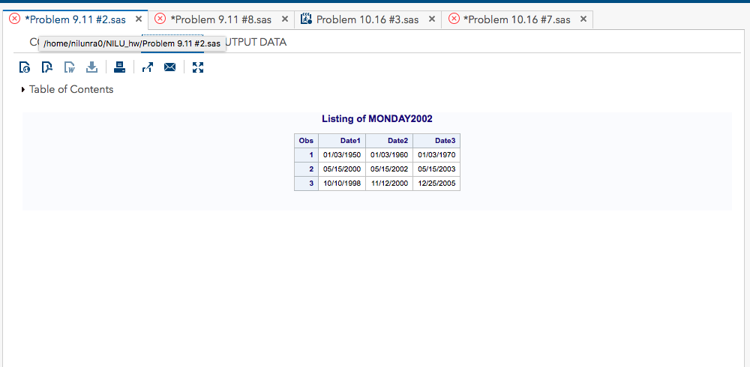

Problem 9.11 #8

/*Nilupul Rathgama for BAN500*/

/*Problem 9.11 #8*/

**data** date_08;

/*the DATA step automatically names each successive data set */

input day month year; input buffer without creating any SAS variables*/

/*if-then statement can be used to create a new variable

for a selected subset of the observations*/

date = mdy(month , day, year);

/* function mdy to create the desired date */

format date mmddyy10.;

/*DATALINES statement with an INPUT statement to read data that you

enter directly in the program, rather than data stored in an external file.*/

datalines;

25 12 2005

1 1 1960

21 10 1946

;

**run**;

**quit**;

**proc** **print** data = date_08 noobs; /*Selecting Variables to Print*/

title 'Date created from the values for Problem 8';

**run**;

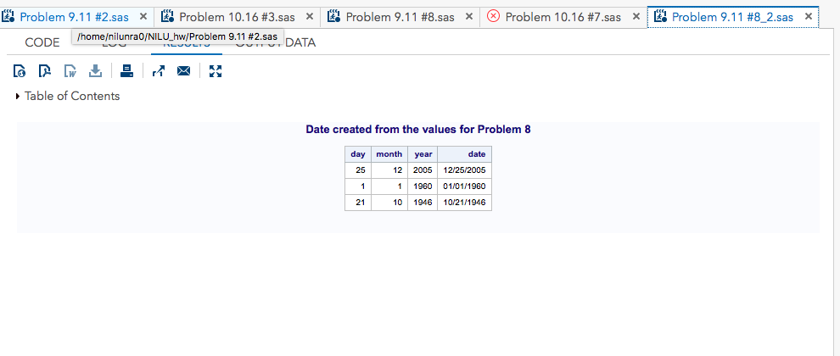

/*Nilupul Rathgama for BAN500*/

/*Problem 10.16 #3*/

filename Blood '/courses/d1612de5ba27fe300/Wks 7&8/blood.txt';

/* access to file to the program */

**data** lowfemale lowmale;

infile Blood missover;

input ID Gender$ Type$ AgeCat$ RBC WBC Chol;

/*brings an input data record into the

input buffer without creating any SAS variables*/

/*if-then statement can be used to create a new variable

for a selected subset of the observations*/

if missing (Chol) or Chol >= **100** then delete;

**run**;

title "Listing of LOWMALE";

**proc** **print** data=lowmale noobs; ;/*Selecting Variables to Print*/

**run**;

title "Listing of LOWFEMALE";

**proc** **print** data=lowfemale noobs;

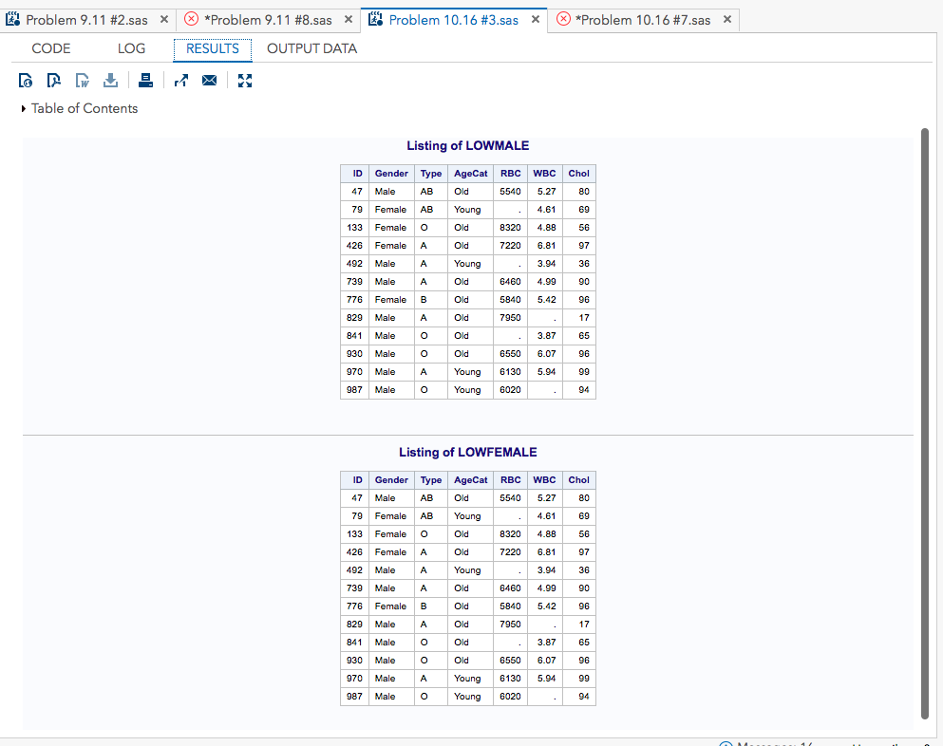**run**;

/*Nilupul Rathgama for BAN500*/

/*Problem 10.16 #7*/

**data** gym;

/*the DATA step automatically names each successive data set */

infile '/home/nilunra0/my_courses/sue.mcdaniel/Wks 7&8/gym.txt' truncover;

input Subj : $3.

Date : mmddyy10.

Fee;

format Date mmddyy8. Fee Dollar6.;

**run**;

**proc** **means** data=gym;

/*PROC MEANS excludes the observations with a missing class variable value from the analysis*/

var Fee;

output out=means(keep=AveFee)

Mean=AveFee;

**run**;

